Gluten Free Reese’s Brownies
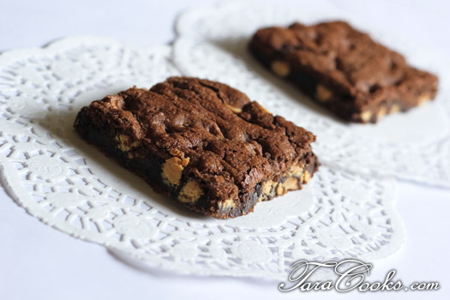
Looking for some great gluten free treats? What better way to satisfy your sweet tooth than with chocolate and peanut butter?
- 2 1/4 sticks real butter softened
- 2 cups sugar
- 3/4 cup cocoa
- 2 teaspoons vanilla
- 2 eggs
- 2 cups Bob's Gluten Free Baking Mix
- 1/2 teaspoon salt
- 1 teaspoon baking soda
- 1 10 oz package Reese's Peanut Butter baking chips (check package for Gluten Free verification)

In large bowl beat butter until light and fluffy. Add sugar, cocoa, and vanilla and blend well. Add 2 eggs and mix well. In a separate bowl mix the flour, salt and baking soda together until well blended. Then add flour mixture to butter sugar cocoa mixture and blend well. Add peanut butter chips and stir. Spread mixture into a 10x14 pan. Place in a preheated 350 degree oven approximately 20 minutes.
www.Taracooks.com

